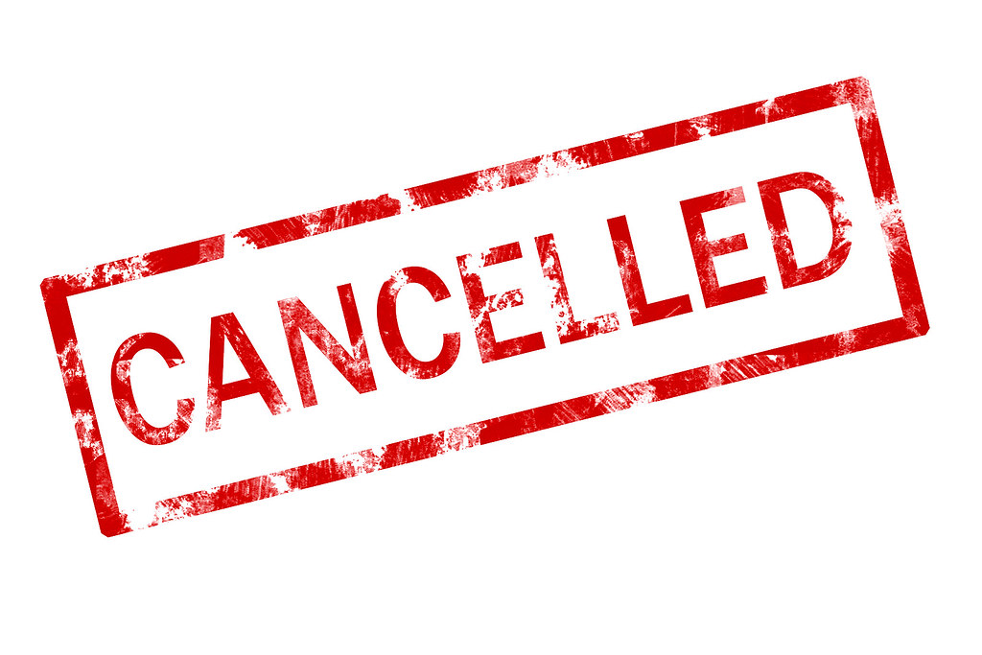
WE APOLOGIES FOR THE INCONVIENENCE, THIS MEETING HAS BEEN CANCELLED.

