**MURPHYS SANITARY DISTRICT**

*“Dedicated to providing a safe wastewater collection and treatment service at fair and reasonable rates for the community of Murphys, preserving and protecting our environment for future generations.”*

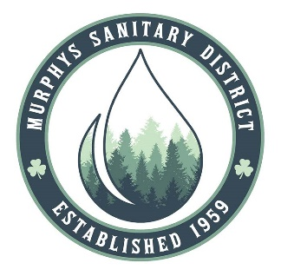

**Regular Board Meeting** **MSD District Office**

Thursday June 12, 2025 15 Ernest Street, Suite A

10:00 a.m. Murphys, CA 95247

**JUNE 12, 2025 REGULAR MEETING HAS BEEN CANCELLED.**

**THE NEXT REGULAR MEETING WILL BE ON**

**THURSDAY, JULY 10, 2025**

**AT 10:00 AM**

In compliance with the Americans with Disabilities Act, if you need special assistance to participate in this meeting, please contact the **Murphys Sanitary District at 209-728-3094**. Notification in advance of the meeting will enable MSD to make reasonable arrangements to ensure accessibility to this meeting. Any documents that are made available to the Board before or at the meeting, not privileged or otherwise protected from disclosure, and related to agenda items, will be made available at MSD for review by the public.